Pupil premium strategy statement – The Peak Academy

This statement details our school’s use of pupil premium (and recovery premium) funding to help improve the attainment of our disadvantaged pupils.
It outlines our pupil premium strategy, how we intend to spend the funding in this academic year and the outcomes for disadvantaged pupils last academic year.

School overview
Detail | Data
Number of pupils in school | 64
Proportion (%) of pupil premium eligible pupils | 81%
Academic year/years that our current pupil premium strategy plan covers (3 year plans are recommended – you must still publish an updated statement each academic year) | September 2023 – August 2026
Date this statement was published | January 2025
Date on which it will be reviewed | December 2025
Statement authorised by | Elisa Entwistle
Pupil premium lead | SENDco
Governor / Trustee lead | TBC

Funding overview
Detail | Amount
Pupil premium funding allocation this academic year including LAC funding. | £41,890
Recovery premium funding allocation this academic year  Recovery premium received in academic year 2023/24 cannot be carried forward beyond August 31, 2024. | £0
Pupil premium funding carried forward from previous years (enter £0 if not applicable) | £ 5,071.38 LAC funding
Total budget for this academic year  If your school is an academy in a trust that pools this funding, state the amount available to your school this academic year | £46,961.38

Part A: Pupil premium strategy plan

Statement of intent
You may want to include information on:
- What are your ultimate objectives for your disadvantaged pupils?
As for all pupils at the academy, our ultimate aim is for them to achieve their best possible outcome and gain qualifications that enable them to identify, access and sustain appropriate post 16 provision. Equipping them to find a place in and make a positive contribution to society.
- How does your current pupil premium strategy plan work towards achieving those objectives?
By supporting pupils to read well, access to the curriculum will be improved, leading to better outcomes. By supporting pupils to self-regulate and develop their social and emotional skills they are able to ask for help and engage in activities more successfully outside of school life
- What are the key principles of your strategy plan?
The key principle of our strategy is to support pupils to grow socially and emotionally so as to remove barriers and improve access to the curriculum and wider life opportunities.

Challenges
This details the key challenges to achievement that we have identified among our disadvantaged pupils.
Challenge number | Detail of challenge
1 | Pupils lack the resilience to cope with academic rigor.
2 | Reading ages are often far below chronological age therefore pupils struggle to access the curriculum.
3 | Social skills and understanding of social expectations are poor.
4 | Inability to self-regulate well and access learning.
5 | Lack of good support and positive role models at home.

Intended outcomes
This explains the outcomes we are aiming for by the end of our current strategy plan, and how we will measure whether they have been achieved.
Intended outcome | Success criteria
Gaps in social and emotional learning have been identified and targeted learning and intervention put in place. | - Sleuth data shows that there are fewer recorded incidents of pupils leaving class.  - Thrive assessments show that pupils make progress in relation to their starting points.
Pupils make more than expected progress in their reading. | - Most pupils improve their reading scores by more than 12 months  - Some pupils with identified learning needs make greater progress than during previous assessment periods.
Pupils are better able to regulate and remain in lessons longer. | - Pupils new to the school have identified strategies to support transition  - Sleuth data for pupils new to the school show reduced incident rates, particularly in regard to leaving lessons  - Pupils with high incident rates have plans in place that support them well, leading to reducing incident rates.
Pupils have opportunity to broaden their social capital. | - All pupils have the opportunity to attend a variety of school trips.  - Positive role models identified for pupils that lack these elsewhere.

Activity in this academic year
This details how we intend to spend our pupil premium (and recovery premium) funding this academic year to address the challenges listed above.

Teaching (for example, CPD, recruitment and retention)
Budgeted cost: £ 15,000
Activity | Evidence that supports this approach | Challenge number(s) addressed
Widen the delivery of the SEL curriculum | IntegratED Supporting the whole child. | 1,2,3,4
Train Senior leader in leading high quality CPD for all staff | Evidence suggests that teacher quality is among the most important determinants of educational achievement (Coe et al., 2020; Hattie, 2009; Burgess, 2016; Allen et al. 2016), second only to pupil background (OECD, 2015). Ensuring every teacher is supported in delivering high-quality teaching is essential to achieving the best outcomes for all pupils, particularly the most disadvantaged among them. | 1,2,3,4
Provide time for coaching and mentoring of teachers | See above | 1,2,3,4

Targeted academic support (for example, tutoring, one-to-one support, structured interventions)
Budgeted cost: £ £15,000
Activity | Evidence that supports this approach | Challenge number(s) addressed
Literacy interventions, including phonics | EEF teaching and learning toolkit. | 2
CPD programme for teaching assistants | EEF teaching and learning toolkit. | 1,2,3,4

Wider strategies (for example, related to attendance, behaviour, wellbeing)
Budgeted cost: £ 16,981
Activity | Evidence that supports this approach | Challenge number(s) addressed
Thrive development and embedding as part of school practice. | The Thrive approach, evidence and impact. | 2,4
Individual pupil mentoring | Youth.gov lists the benefits of mentoring as:  - Increased high school graduation rates  - Lower high school dropout rates  - Healthier relationships and lifestyle choices  - Better attitude about school  - Higher college enrolment rates and higher educational aspirations  - Enhanced self-esteem and self-confidence  - Improved behaviour, both at home and at school  - Stronger relationships with parents, teachers, and peers  - Improved interpersonal skills  - Decreased likelihood of initiating drug and alcohol use (MENTOR, 2009; Cavell, DuBois, Karcher, Keller, & Rhodes, 2009)  However it is recognised that educational benefits may stop when the mentoring stops. | 5
Supporting HTR pupils to remain on school site and access school curriculum for as much of their timetable as is practicable. Through development of ABC House and increased support on the ground. | School data 23.24 shows pupils achieve their best possible outcomes when accessing provision in school rather than through AP. | 4
Extra curricular activities | Social Mobility Commission, An unequal playing field. | 5

Total budgeted cost: £ £53,610

Part B: Review of the previous academic year

Outcomes for disadvantaged pupils
Sleuth data shows a decrease in incidents of negative behaviour over the 22-23 academic year, see graph below.

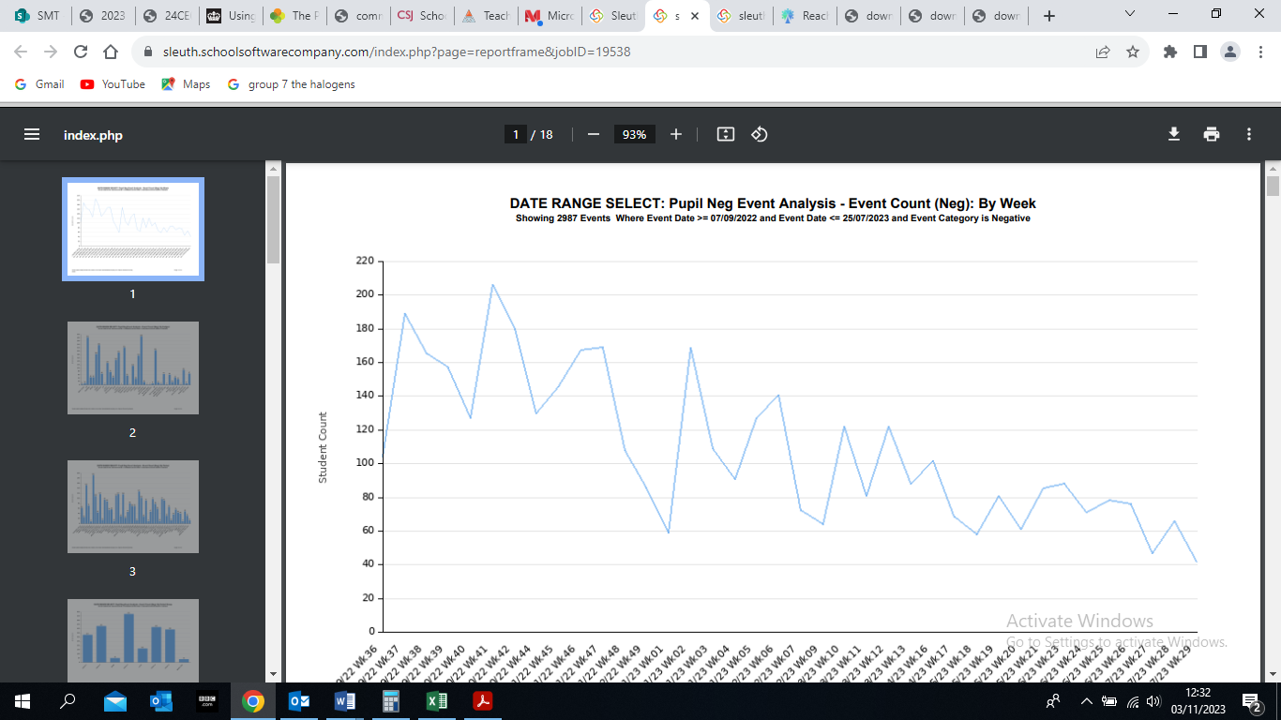
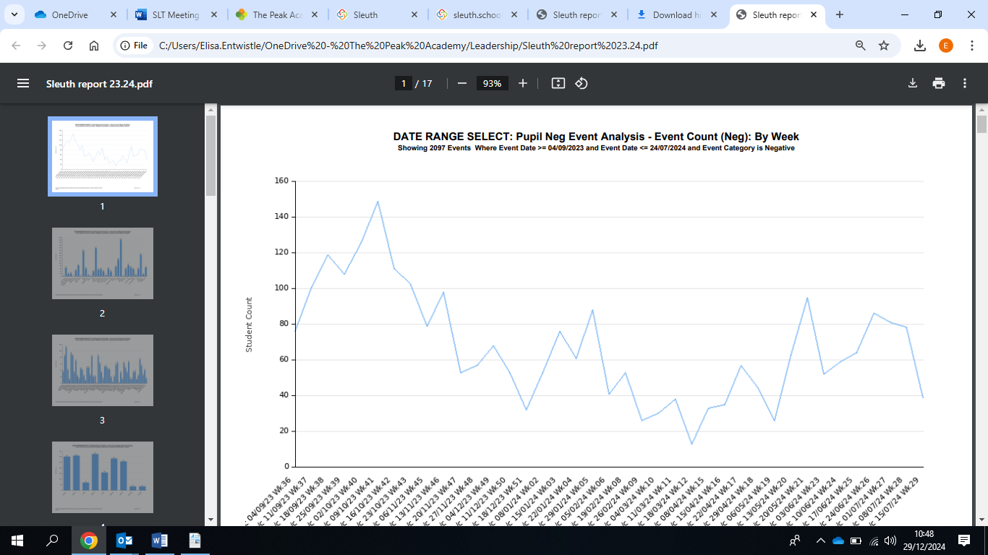
The number of incidents fell again during 23.24 and largely showed a downward trend:

RPIs fell from 251 incidents recorded in 21-22 to 169 incidents in 22-23 and to 123 incidents in 23.24.
Suspensions dropped from 81 suspensions in 21.22 to 73 in 22.23, however the number of days lost to suspensions rose from 181 to 216.5 between 21.22 and 22.23. In 23/24 there were 41 incidents totalling 100 days.
Pupils with highest number of incidents recorded during 23.24:
Of the top 5 PP pupils, 3 show a downward trend in number of incidents.
Attendance data shows:
All school, 1% increase between T1 and T6.
Disadvantaged increase of 0.8% between T1-T6.
T6 – T1 all school 4.7%
T6 -T1 disadvantaged 4.8%

Reading data 23.24 shows:
More pupils improved their score by 12 months than did not, average increase was 2y3m. – 47% made more than 12 months progress. Pupil premium pupils increased their reading age by 1y7m.
Progress data in Maths and English shows:
In English the percentage of PP pupils below target fell from 86% to 56% over the academic year.
In Maths the percentage of PP pupils below target increased from 34% to 47%.
All pupils had access to whole school trips that were well attended, including a trip to Bath theatre, HMS Great Britain and a DfE walk. Other trips were provided for specific groups such as food trips to Ludlow food festival and the NEC, and a number of sports fixtures.

Externally provided programmes
Please include the names of any non-DfE programmes that you used your pupil premium (or recovery premium) to fund in the previous academic year.
Programme | Provider

